INDUSTRY INTERNSHIP REPORT
On


“Java Fullstack”
An Internship report submitted in partial fulfillment of requirements for the award of degree of
BACHELOR OF TECHNOLOGY
COMPUTER SCIENCE AND ENGINEERING

By
Gali Iswarya (239X5A05L4)
Under the esteemed guidance of P.Sunandha
Associate Professor Department of C.S.E.

Department of Computer Science and Engineering

G. PULLA REDDY ENGINEERING COLLEGE (Autonomous): KURNOOL
(Affiliated to JNTUA,Ananthapuramu)
KURNOOL – 518007
2025 – 2026

Department of Computer Science and Engineering

G. PULLA REDDY ENGINEERING COLLEGE (Autonomous): KURNOOL
(Affiliated to JNTUA, ANANTHAPURAMU)



CERTIFICATE

This is to certify that the internship titled ‘Java Fullstack’ is a bonafide record of work carried out by Gali Iswarya (239X5A05L4) and the Internship report is submitted in partial fulfillment of requirements for the award of degree of Bachelor of Technology in Computer Science and Engineering.

…………………………….. . ……………………………..
P.Sunandha Dr. N. Kasiviswanath
Associate Professor Professor & Head of the Department,
Department of C.S.E., Department of C.S.E.,
G. Pulla Reddy Engineering College, G. Pulla Reddy Engineering College,
Kurnool. Kurnool.

INTERNSHIP DETAILS

Name of the College : G. Pulla Reddy Engineering College
Department : Computer Science and Engineering
Name of the Student : Gali Iswarya
Register Number : 239X5A05L4
Name of the Guide : Mr. S Monsoor Ali
Duration of the Internship : From 15-12-2025 to 10-04-2026
Name and address of the Organization : codeon technologies, reddy bhavan line, karkambadi road, Tirupati, 517501
Internship Domain : Java Fullsatck
Internship Stipend : No Stipend
Date of Internship Report Submission : 18-04-2026

Internship Coordinator
Dr. B. Geetha Vani Professor
CSE Department GPREC

DECLARATION

I Gali Iswarya, a student bearing the Roll No. 239X5A05L4, of the Department of Computer Science and Engineering, G. Pulla Reddy Engineering College, do hereby declare that the I have completed the mandatory internship Java Full Stack from 15-12-2025 to 10-04-2026 in Codeon Technologies under the Guide ship of Mr. S Mansoor Ali.

(Student Signature and Date)

Certificate from Organization
This is to certify that Gali Iswarya 239X5A05L4 of G. Pulla Reddy Engineering College underwent Internship in Codeon Technologies from 15-12-2025 to 10-04-2026.
The overall performance of the Intern during her internship is found to be good.



Internship completion certificate

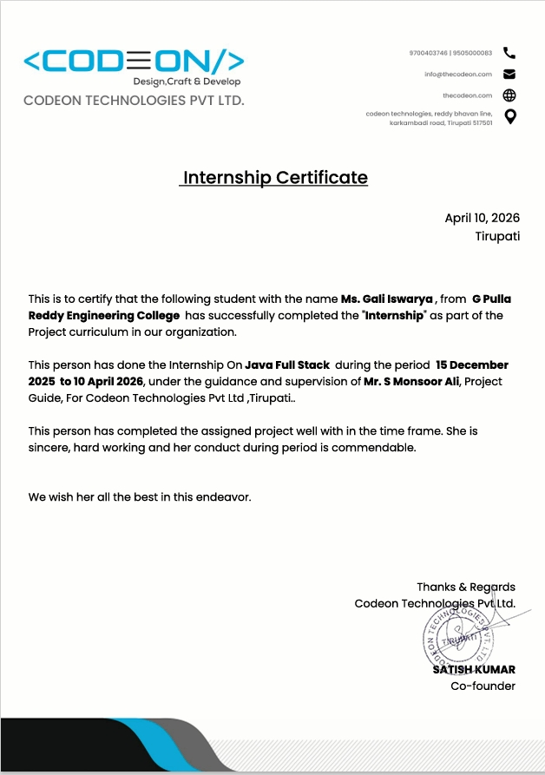

ACKNOWLEDGEMENT

I wish to express my deep sense of gratitude to my internal supervisor P.Sunandha, Associate Professor of Computer Science and Engineering Department, G. Pulla Reddy Engineering College.
My sincere thanks to our Internship Coordinator Dr. B. Geetha Vani, Professor of CSE for her immaculate guidance, constant encouragement and cooperation which have made possible to bring out this internship work.
My sincere thanks to Mr. S Mansoor Ali, Technical Mentor, of Codeon Technologies, for helping me and giving me the required information needed for my internship work.
I am thankful to our Head of the Department Dr. N. Kasiviswanath, for his whole hearted support and encouragement during the internship.
We are grateful to our Internship Dean Dr. Y. V. Siva Reddy and to our respected Principal Dr. B. Sreenivasa Reddy for providing requisite facilities and helping us in providing such a good environment.
I wish to convey my acknowledgements to all the staff members of the Computer Science and Engineering Department for giving the required information needed for my internship work.
Finally, I wish to thank all our friends and well-wishers who have helped me directly or indirectly during the course of this internship work.

Table of Contents

CHAPTER Page No
- INTRODUCTION
  - About the Internship Company/Organization 1
  - Virtual/Offline Internship details 4
- WORK DONE DURING INTERNSHIP
  - About Course/Domain 8
  - Technologies learnt during internship 16
- PROJECTS/MODULES COMPLETED
  - About Project 19
- ACTIVITY LOG 43
- CONCLUSION 48
- REFERENCES 50

List of Figures

FIGURE NO. FIGURE NAME
Figure 3.1.1 | Architecture of Employee Management System (Frontend–Backend–Database Interaction)
Figure 3.1.2 | React Component Structure for Employee Form
Figure 3.1.3 | Database Schema Diagram for Employee and Department Tables
Figure 3.1.4 | Flowchart of CRUD Operations in EMS
Figure 3.1.5 | Unit Testing Workflow for EMS
Figure 3.2.1 | EMI Calculator User Interface Layout (HTML & CSS)
Figure 3.2.2 | JavaScript Logic Flow for EMI Calculation
Figure 3.2.3 | Pie Chart Visualization of Principal vs. Interest
Figure 3.2.4 | Speedometer Indicator for Loan Risk Categories
Figure 3.2.5 | Bar Chart Representation of Loan Repayment Schedule
Figure 3.2.6 | Sample Output Table Generated by EMI Calculator
Figure 3.2.7 | Code Implementation Snippet for EMI Formula in JavaScript

1.INTRODUCTION

About the Internship Company/Organization:

The internship was undertaken at Codeon Technologies Pvt. Ltd., a dynamic and technology-driven organization founded in 2019 and headquartered in Tirupati, India. Since its inception, the company has steadily grown into a reliable provider of innovative software solutions and industry-oriented training programs. With a strong focus on developing smart, scalable, and future-ready SaaS applications, Codeon Technologies has positioned itself as a trusted partner for startups, enterprises, and government organizations. Its services span across customized software solutions, cloud-based platforms, AI-driven tools, and complete end-to-end full-stack development services, making it a versatile player in the technology sector.

The organization operates with a clear vision of driving digital transformation by building efficient, intelligent, and sustainable software systems. With a team of highly skilled professionals that includes developers, designers, and technical mentors, Codeon Technologies emphasizes quality, scalability, and innovation in every solution it delivers. The company not only focuses on product development but also plays a crucial role in shaping the next generation of software engineers. By offering practical and industry-relevant training programs, it ensures that students are well-prepared to meet the demands of modern software development environments.

A key highlight of Codeon Technologies is its Java Full Stack Development training program, which is carefully designed to bridge the gap between academic knowledge and real-world industry requirements. The curriculum is comprehensive and structured, covering a wide range of technologies such as Core Java, Advanced Java, JDBC, Servlets, JSP, and modern frameworks like Spring and Spring Boot. Alongside back-end technologies, the program also includes front-end development using HTML, CSS, JavaScript, and Bootstrap, as well as database management systems. This integrated approach ensures that students gain a holistic understanding of both client-side and server-side development, enabling them to build complete, functional applications.

The training methodology adopted by the company strongly emphasizes hands-on learning and real-time project development. Rather than focusing solely on theoretical concepts, students are encouraged to apply their knowledge through coding exercises, assignments, and practical projects. This approach helps in strengthening problem-solving skills, logical reasoning, and confidence in developing scalable applications. By consistently engaging in real-world exercises, learners are able to internalize concepts and understand their relevance in professional software engineering.
As part of the internship, students gain practical exposure by working on projects that simulate real-world applications. One such project was a Temperature Converter web application, developed using HTML, CSS, JavaScript, and Bootstrap. This application allowed users to convert temperature values between Celsius, Fahrenheit, and Kelvin. To enhance its functionality, the OpenWeather API was integrated, enabling the application to fetch real-time temperature data from different cities. This project provided valuable insights into API integration, responsive UI design, and client-side logic implementation, while also demonstrating the ability to combine core web technologies with external services.

In addition to frontend development, a major Java Full Stack project titled “Sphere” was developed. Sphere is a unified project management system inspired by platforms such as Jira, designed to manage tasks, track progress, and facilitate team collaboration. The application introduced trainees to Agile working principles, incorporating Scrumban-based features that allow users to organize workflows, monitor sprint activities, and collaborate effectively within teams. This project provided a simulated real-world environment, enabling students to understand how professional project management systems operate and preparing them to adapt to Agile methodologies in industry settings.

Through these projects, Codeon Technologies ensures that students gain real-world hands-on experience, making them industry-ready and capable of adapting to professional environments with ease. The organization’s focus on combining theoretical knowledge with practical implementation significantly enhances technical proficiency, strengthens logical thinking, and prepares learners to meet modern software development challenges.

Overall, Codeon Technologies provides a comprehensive learning and development platform where students not only acquire technical knowledge but also gain valuable practical experience through real-time project execution. This holistic approach ultimately prepares them for successful careers in the software industry, equipping them with both the technical expertise and professional mindset required to thrive in today’s competitive digital landscape.

Additional Information:

Official Page: https://plasmid.co.in/

Course Page (Internship Domains): https://intrainz.mykademy.com/login

IIITDM Intern – LinkedIn: https://www.linkedin.com/company/plasmid23/
Login Page: https://intrainz.mykademy.com/login

1.2 Offline Internship details:

Training Phase
The internship was conducted at Codeon Technologies, a reputed organization with more than six years of experience in delivering high-quality training and development solutions in the field of software engineering. The company has built a strong reputation for equipping students with industry-relevant skills by combining theoretical knowledge with extensive hands-on practical exposure. Their primary focus is on preparing learners for careers in Java full-stack development, ensuring that participants are capable of handling both frontend and backend technologies with confidence.

Codeon Technologies follows a structured, industry-oriented training methodology that bridges the gap between academic learning and real-world application. The curriculum is carefully designed to progress in a logical sequence, beginning with foundational programming concepts and gradually advancing toward full-stack development using modern tools and frameworks. This step-by-step approach ensures that students not only understand the basics but also develop the ability to apply advanced concepts in practical scenarios. The training environment is highly interactive, incorporating live sessions, coding exercises, group discussions, and real-time project implementation. This fosters continuous engagement, encourages collaborative learning, and helps participants gain a deeper understanding of the subject matter.

A major strength of the internship program lies in its emphasis on practical learning. Every theoretical concept introduced during the sessions was reinforced through assignments, coding challenges, and mini-projects. This hands-on methodology enabled students to strengthen their problem-solving abilities, improve logical thinking, and gain confidence in developing applications independently. By consistently applying knowledge in real-time exercises, learners were able to internalize concepts and understand their relevance in professional software development.

During the internship, multiple projects were undertaken to demonstrate the acquired technical skills. On the frontend side, a Temperature Converter web application was developed using HTML, CSS, JavaScript, and Bootstrap. This application allowed users to convert temperature values between Celsius, Fahrenheit, and Kelvin. To make the project more dynamic and realistic, the OpenWeather API was integrated, enabling the application to fetch real-time temperature data from different cities. The use of Bootstrap ensured that the interface was responsive, visually appealing, and user-friendly, thereby enhancing the overall user experience. This project highlighted the ability to combine core web technologies with external APIs and modern UI frameworks to build practical applications.

In addition to frontend development, a comprehensive Java Full Stack project titled “ProjectSphere” was developed. ProjectSphere is a unified project management system inspired by platforms like Jira, designed to manage tasks, track progress, and facilitate team collaboration. The project provided a simulated real-world working environment where trainees could gain hands-on experience in handling project workflows. It also introduced participants to Agile methodologies, helping them understand how iterative development and team-based collaboration function in professional organizations.

The Sphere platform incorporated features inspired by Scrum and Kanban (Scrumban), allowing users to manage tasks through organized workflows, track sprint progress, and collaborate efficiently within teams. This exposure gave learners practical insights into how Agile environments operate in real organizations, preparing them to adapt quickly to industry practices. By working on ProjectSphere, trainees not only strengthened their technical skills but also developed an understanding of project management, teamwork, and communication in a professional setting.

The successful completion of these projects demonstrates the effectiveness of Codeon Technologies’ training approach, where theoretical concepts are consistently supported by practical implementation. This internship experience significantly enhanced technical proficiency, improved logical and analytical thinking, and provided valuable exposure to real-world development practices. Ultimately, the program prepared students to meet industry expectations with confidence, equipping them with both the technical expertise and professional mindset required to excel in software engineering roles.

Program Structure

Duration: Typically 15 weeks

Training Hours: Over 30 hours of instruction

Projects: 2 hands-on projects to apply learned skills

Certification: Industry-recognized certificate upon completion

Mentorship: Guidance from experienced professionals

2.Work Done During Internship

2.1 About the Domain
During my internship, I worked extensively in the domain of Java Full Stack Development, with a primary focus on the design and development of real-time web applications that seamlessly integrate both front-end and back-end technologies. The training program was structured to provide a gradual yet comprehensive learning experience, beginning with the fundamentals of web development and progressing toward advanced frameworks and enterprise-level application development.
On the front-end side, I gained practical exposure to technologies such as HTML, CSS, and JavaScript, which are the building blocks of modern web applications. Through hands-on exercises, I learned how to structure web pages, style them for visual appeal, and add interactivity to enhance user experience. Additionally, I worked with Bootstrap, a powerful front-end framework, to design responsive layouts that adapt to multiple devices and screen sizes. This phase of the training emphasized the importance of creating user-friendly interfaces and highlighted how front-end design directly impacts usability and accessibility.
For database management, I studied and practiced SQL, which provided me with the ability to create, manipulate, and query relational databases. I learned how to design tables, establish relationships, and perform operations such as insert, update, delete, and join queries. This knowledge was crucial in understanding how data is stored, retrieved, and managed in real-world applications, forming the backbone of dynamic web systems.
On the programming side, I strengthened my foundation in Core Java and Advanced Java, covering essential concepts such as object-oriented programming, inheritance, polymorphism, exception handling, and multithreading. These concepts were reinforced through problem-solving exercises and small projects, which helped me develop logical thinking and coding efficiency.
The back-end training introduced me to modern frameworks and enterprise-level technologies. I gained hands-on experience with Spring Framework, which provided a robust foundation for building scalable applications. I explored Spring Boot, which simplified application setup and configuration, enabling rapid development of production-ready applications. I also worked with REST APIs, learning how to design and implement endpoints that allow communication between client-side interfaces and server-side logic.

Further, I studied JPA (Java Persistence API) and Spring Data JPA, which streamlined database interactions by abstracting complex SQL queries into simple repository methods. I also worked with Hibernate, a widely used ORM (Object-Relational Mapping) tool, to manage database operations efficiently. Additionally, I was introduced to AOP (Aspect-Oriented Programming), which helped me understand how cross-cutting concerns such as logging, security, and transaction management can be modularized and applied across applications without cluttering the core business logic.
The internship placed strong emphasis on building scalable and efficient applications by integrating these technologies into a complete full-stack architecture. This exposure provided me with a clear understanding of how client-side interfaces interact with server-side logic and databases in real-world applications. By working on practical assignments and projects, I was able to see how each layer of the stack contributes to the overall functionality of an application.
Beyond technical skills, the domain training also focused on problem-solving, application architecture, and industry best practices. I learned how to structure applications for maintainability, follow coding standards, and adopt design patterns that improve efficiency and scalability. This holistic approach ensured that I was not only learning technologies in isolation but also understanding how they fit together in professional software development.
Overall, this internship experience provided me with strong practical knowledge of full-stack development, covering both front-end and back-end technologies. It prepared me to build, deploy, and maintain real-world applications, while also instilling confidence in working with modern frameworks and industry practices. The combination of theoretical learning, hands-on exercises, and project-based implementation has significantly enhanced my technical proficiency and readiness to contribute effectively in professional software engineering environments.

2.2 Project 1: ProjectSphere – Unified Project Management System
Overview
The ProjectSphere is a full-stack web application developed as a unified project management platform, similar to tools like Jira. It is designed to help teams manage tasks, track project progress, and collaborate effectively within an organization. The platform provides a structured environment that simulates real-world software development workflows, especially in Agile-based environments.
Work Done
- Frontend (Angular): Developed dynamic and responsive user interfaces using Angular, including dashboards, task boards, and forms for managing project activities. Implemented interactive components to enhance user experience and workflow visualization.
- Backend (Spring Boot): Built RESTful APIs using Spring Boot to handle core functionalities such as task management, user roles, and project tracking. Ensured efficient request handling and application performance.
- Database (Spring Data JPA & Hibernate): Used JPA and Hibernate for object-relational mapping and database operations. Designed structured database schemas and managed data persistence efficiently.
- Agile & Workflow Implementation: Implemented features inspired by Agile methodologies, including Scrumban-based task management, enabling users to organize workflows, track progress, and manage tasks effectively.
- Testing: Performed testing to ensure smooth functionality, resolved bugs, and improved application performance and reliability.
Outcomes
This project significantly enhanced my understanding of Java Full Stack Development by integrating front-end and back-end technologies into a single application. It improved my skills in API development, database management, and application architecture. Additionally, it provided real-world exposure to Agile workflows, team collaboration, and project management practices, preparing me for professional software development environments.

2.3 Project 2: Smart Temperature Converter
Overview
The Smart Temperature Converter is an interactive front-end web application that provides real-time weather information along with temperature conversion features. It uses the OpenWeather API to fetch live data and displays it through a user-friendly interface.
Work Done
- Frontend (HTML & CSS): Designed a responsive and visually appealing user interface using HTML, CSS, and Bootstrap. Implemented card-based layouts and popup components to display weather details in a structured and attractive format.
- API Integration (OpenWeather API): Integrated the OpenWeather API to fetch real-time weather data. Implemented two dropdowns—one for selecting an Indian state and another for dynamically displaying major cities based on the selected state. Upon selecting a city, real-time temperature and weather details are fetched and displayed.
- Dynamic Features (JavaScript): Implemented dynamic updates, event handling, and weather-based animations such as sunny, rainy, and cloudy.
- Functionality: Displayed temperature, air and wind details in popup cards, compared temperatures between cities using charts, and added a temperature converter with a thermometer-style animation.
Outcomes
This project significantly enhanced my skills in JavaScript, API integration, and dynamic web development. It provided practical experience in working with real-time data, building interactive UI components, and implementing animations for better user experience. Additionally, it demonstrated how front-end technologies can be used to develop real-world applications that are both functional and visually engaging

PROJECTS/MODULES COMPLETED

3.1 Project 1: ProjectSphere – Unified Project Management System

3.1.1 Project Description

ProjectSphere is a full-stack web application developed as a unified project management platform, designed to simulate real-world software development environments. The primary objective of this system is to help trainees and employees understand, adapt, and work efficiently in Agile environments. It provides a structured platform where users can manage projects, track progress, collaborate with teams, and follow modern development workflows similar to industry tools like Jira.

The system supports role-based access control, enabling different functionalities for Admin, Project Manager, and Team Member. It focuses on improving project visibility, task management, and team collaboration while maintaining proper workflow structure. By integrating Agile concepts such as product backlog, sprint planning, task boards, and sprint history, the application ensures that users gain hands-on experience in managing real-world projects.

ProjectSphere also emphasizes tracking and accountability by recording every activity such as task updates, status changes, and workflow transitions in the database. This helps in monitoring progress, evaluating performance, and maintaining transparency across teams. Additionally, features like defect management, analytics, and team communication make the system a comprehensive solution for project handling and learning Agile methodologies.

3.1.2 Technologies Used
ProjectSphere was developed using a modern full-stack technology stack that ensures scalability, performance, and maintainability.
Angular (Frontend): Angular was used to build a dynamic and responsive user interface for ProjectSphere. It helped in creating reusable components such as dashboards, task boards, and forms. Features like two-way data binding ensured smooth data updates between UI and backend, while its modular structure improved code organization. It also supported drag-and-drop functionality for managing tasks across different workflow stages.
Spring Boot (Backend): Spring Boot was used to develop backend services and RESTful APIs. It handled business logic, request processing, and communication between frontend and database. The application implemented JWT-based authentication for secure login and role-based access control, ensuring that different users (Admin, Project Manager, Team Member) have appropriate permissions.
MySQL (Database): MySQL was used to store all application data, including users, projects, tasks, and workflows. The database was structured with proper relationships to maintain data consistency and integrity. It enabled efficient storage and retrieval of data, supporting the overall performance of the system.
Spring Data JPA & Hibernate: Spring Data JPA and Hibernate were used for database interaction and object-relational mapping. They simplified CRUD operations and reduced the need for writing complex SQL queries. These technologies also helped in managing relationships between entities and ensured smooth data handling within the application.

Together, Angular, Spring Boot, and MySQL formed a powerful combination for building the ProjectSphere application. Angular handled the presentation layer by providing an interactive and responsive user interface, while Spring Boot managed the business logic and RESTful API services. MySQL ensured reliable and structured data storage for users, projects, and workflows. This integration resulted in a full-stack application that is scalable, maintainable, and user-friendly. The use of these technologies reflects industry best practices and provided valuable hands-on experience in working with a professional full-stack architecture.

3.1.3 Work Done
- Authentication & Role Management::
  - A secure authentication system was implemented using JWT (JSON Web Token) to ensure safe login and session management. Role-based access control was defined for three main roles: Admin, Project Manager, and Team Member. Each role was assigned specific permissions, ensuring that users could only access the functionalities relevant to their responsibilities. This improved both security and system organization.
- Admin Module:
  - The Admin module was designed as the central control unit of the system. An interactive admin dashboard was developed to display key metrics such as the number of ongoing projects, completed projects, teams, and project managers.
The admin has the authority to create and manage user accounts, including Project Managers and Team Members, by uploading their details through Excel sheets, which are then stored in the database.
Additionally, the admin has full access to all project workspaces, allowing complete monitoring of project progress, as well as the ability to view and manage user profiles across the system.

- Project Manager Module:
  - The Project Manager module enables managers to efficiently handle assigned projects and oversee team activities. Project Managers can view the list of projects they are responsible for and manage the respective workspaces.
They can track task progress, monitor team performance, and evaluate team members based on their contributions and efficiency.
The module also supports communication between the Project Manager, team members, and team leads, ensuring smooth coordination and workflow management.
- Team Member Module:
  - The Team Member module focuses on task execution and contribution. Team members can create user stories, which are automatically stored in the product backlog.
They can select tasks from the backlog, move them into active sprints, and update their status as they progress through different stages.
This module allows team members to actively participate in the development process while maintaining transparency in task updates.
- Agile Workflow Implementation:
  - The system follows a Scrumban-based Agile workflow, combining features of both Scrum and Kanban methodologies. It includes modules such as Product Backlog, Sprint Planning, Sprint History, and Task Board.
The task board visually represents workflow stages using columns like To Do, In Progress, Testing, and Completed. Tasks can be moved across these stages using drag-and-drop functionality, making the workflow intuitive and easy to manage.
- Tracking & Data Management:
  - A comprehensive tracking mechanism was implemented where every activity—such as task creation, movement between stages, and status updates—is recorded in the database.
This ensures complete transparency and allows for detailed tracking of project progress, making it easier to analyze performance and maintain accountability.
- Additional Features:
  - The system includes a defect management module that allows users to report, track, and resolve issues efficiently.
An analytics dashboard was developed to display insights such as individual developer contributions, number of defects raised, and resolved tasks.
Additionally, a team information module was included to provide details about the project structure, including the Project Manager, Team Lead, and Team Members, ensuring clarity in team roles and responsibilities.

3.1.4 Outcomes & Learnings
• Full Stack Development Experience:
Practical experience in developing a complete Java Full Stack application was one of the most valuable outcomes of this project. By working on ProjectSphere, I learned how to integrate frontend and backend technologies, ensuring smooth communication between Angular, Spring Boot, and MySQL. This strengthened my understanding of full-stack architecture and real-world application development.
REST API & Backend Development:
Gained strong knowledge in REST API development and backend logic implementation using Spring Boot. I was able to design APIs for handling user management, project workflows, and task tracking. This improved my ability to structure backend services efficiently and handle client-server communication effectively.
Database Design & ORM:
Improved understanding of database design and ORM (Object Relational Mapping) using Spring Data JPA and Hibernate. I learned how to create entity relationships, manage data persistence, and ensure data consistency across multiple modules such as users, projects, and tasks.
Authentication & Authorization:
Hands-on experience with JWT authentication and role-based access control was another key learning. Implementing secure login for Admin, Project Manager, and Team Member roles helped me understand how authentication and authorization work in real-world applications.
Agile Methodologies:
Gained practical exposure to Agile methodologies, including Scrum, Kanban, and Scrumban workflows. By implementing features like product backlog, sprint management, and task boards, I understood how projects are managed in real industry environments.

3.1.5 Skills Gained During Internship

• Java Full Stack Development
• Angular Frontend Development
• Spring Boot & REST API Development
• Spring Data JPA & Hibernate
• MySQL Database Management
• JWT Authentication & Role-Based Access
• Agile Methodologies (Scrum, Kanban, Scrumban)
• Problem Solving & Logical Thinking
• Debugging and Testing
    - Tasks Assigned During Internship

• Developed ProjectSphere (Java Full Stack project)
• Implemented role-based authentication using JWT
• Designed and developed REST APIs using Spring Boot
• Created database schema and managed data using MySQL
• Built dynamic UI components using Angular
• Implemented Agile workflow features like backlog, sprint, and task board
• Tested application functionality and resolved bugs
    - Code Implementation

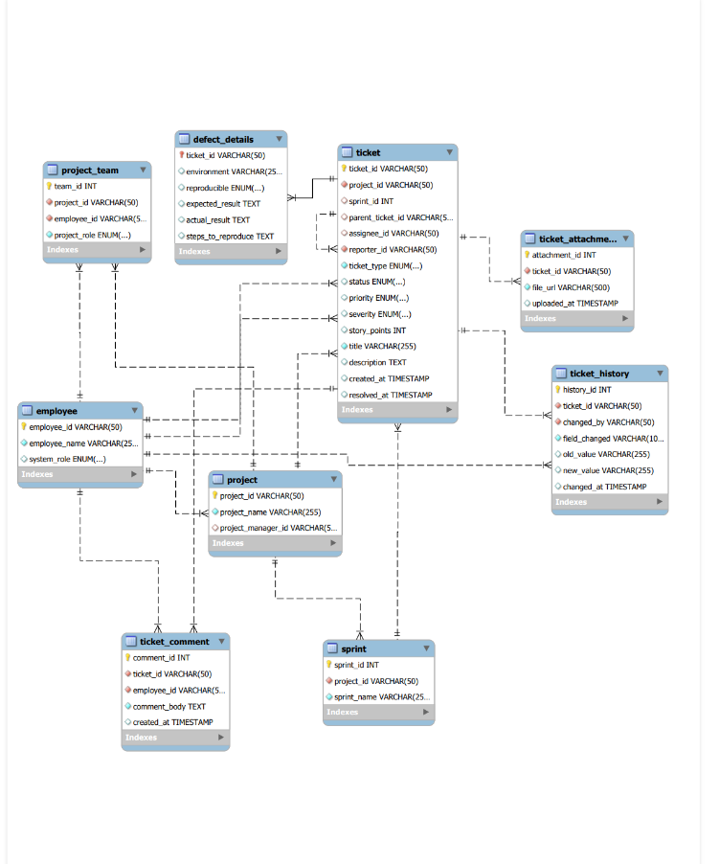

- Security Config:

package com.cts.mfrp.project_sphere.config;
@Configuration
@EnableWebSecurity
@EnableMethodSecurity // Enables @PreAuthorize
@RequiredArgsConstructor
public class SecurityConfig {
private final JwtAuthenticationFilter jwtAuthFilter;
@Bean
public SecurityFilterChain securityFilterChain(HttpSecurity http) throws Exception {
http
.csrf(AbstractHttpConfigurer::disable)
.cors(Customizer.withDefaults())
.authorizeHttpRequests(auth -> auth
.requestMatchers("/api/v1/auth/**").permitAll() .requestMatchers("/api/v1/admin/**").hasRole("ADMIN")
hasAuthority()
.anyRequest().authenticated() .anyRequest().permitAll()
)
.sessionManagement(session -> session.sessionCreationPolicy(SessionCreationPolicy.STATELESS)) .authenticationProvider(authenticationProvider)
.addFilterBefore(jwtAuthFilter, UsernamePasswordAuthenticationFilter.class);
return http.build();
}
}

- Comment controller:

package com.cts.mfrp.project_sphere.controller;
@RestController
@RequestMapping("/api/comments")
public class CommentController {
@Autowired
private CommentService commentService;
@GetMapping
public List<Comment> getAllComments() {
return commentService.getAllComments();
}
@GetMapping("/{id}")
public ResponseEntity<Comment> getCommentById(@PathVariable Long id) {
Optional<Comment> comment = commentService.getCommentById(id);
return comment.map(ResponseEntity::ok)
.orElse(ResponseEntity.notFound().build());
}
@PostMapping
public Comment createComment(@RequestBody Comment comment) {
return commentService.createComment(comment);
}
@PutMapping("/{id}")
public ResponseEntity<Comment> updateComment(@PathVariable Long id,
@RequestBody Comment updatedComment) {
Optional<Comment> updated = commentService.updateComment(id, updatedComment);
return updated.map(ResponseEntity::ok)
.orElse(ResponseEntity.notFound().build());
}
@DeleteMapping("/{id}")
public ResponseEntity<Void> deleteComment(@PathVariable Long id) {
boolean deleted = commentService.deleteComment(id);
return deleted ? ResponseEntity.noContent().build()
: ResponseEntity.notFound().build();
}
@GetMapping("/user/{userId}")
public List<Comment> getCommentsByUser(@PathVariable Long userId) {
return commentService.getCommentsByUser(userId);
}
@GetMapping("/ticket/{ticketId}")
public List<Comment> getCommentsByTicket(@PathVariable Long ticketId) {
return commentService.getCommentsByTicket(ticketId);
}
}
- Comment service:

package com.cts.mfrp.project_sphere.service;

@Service

public class CommentService {

@Autowired

private CommentRepository commentRepository;

public List<Comment> getAllComments() {

return commentRepository.findAll();

}

public Optional<Comment> getCommentById(Long id) {

return commentRepository.findById(id);

}

public Comment createComment(Comment comment) {

return commentRepository.save(comment);

}

public Optional<Comment> updateComment(Long id, Comment updatedComment) {

return commentRepository.findById(id).map(existing -> {

existing.setCommentBody(updatedComment.getCommentBody());

existing.setCreatedAt(updatedComment.getCreatedAt());

existing.setTicket(updatedComment.getTicket());

existing.setUser(updatedComment.getUser());

return commentRepository.save(existing);

});

public boolean deleteComment(Long id) {

return commentRepository.findById(id).map(existing -> {

commentRepository.delete(existing);

return true;

}).orElse(false);

}

public List<Comment> getCommentsByUser(Long userId) {

return commentRepository.findByUser_UserId(userId);

}

public List<Comment> getCommentsByTicket(Long ticketId) {

return commentRepository.findByTicket_TicketId(ticketId);

}
- Comment Repository:

package com.cts.mfrp.project_sphere.repository;
import com.cts.mfrp.project_sphere.model.Comment;
import org.springframework.data.jpa.repository.JpaRepository;
import java.util.List;
public interface CommentRepository extends JpaRepository<Comment, Long> {
List<Comment> findByUser_UserId(Long userId);
List<Comment> findByTicket_TicketId(Long ticketId);
}
- JWT Authentication Filter
package com.cts.mfrp.project_sphere.config;
import com.cts.mfrp.project_sphere.service.JwtService;
import jakarta.servlet.FilterChain;
import jakarta.servlet.ServletException;
import jakarta.servlet.http.HttpServletRequest;
import jakarta.servlet.http.HttpServletResponse;
import org.springframework.security.authentication.UsernamePasswordAuthenticationToken;
import org.springframework.security.core.context.SecurityContextHolder;
import org.springframework.security.core.userdetails.UserDetails;
import org.springframework.security.core.userdetails.UserDetailsService;
import org.springframework.stereotype.Component;
import org.springframework.web.filter.OncePerRequestFilter;
import java.io.IOException;
@Component
@RequiredArgsConstructor
public class JwtAuthenticationFilter extends OncePerRequestFilter {
private final JwtService jwtService;
private final UserDetailsService userDetailsService;
@Override
protected void doFilterInternal(HttpServletRequest request, HttpServletResponse response, FilterChain filterChain)
throws ServletException, IOException {
System.out.println("1");
final String authHeader = request.getHeader("Authorization");
if (authHeader == null || !authHeader.startsWith("Bearer ")) {
filterChain.doFilter(request, response);
return;
}
System.out.println("2");
final String jwt = authHeader.substring(7);
final String userEmail = jwtService.extractUsername(jwt);
if (userEmail != null && SecurityContextHolder.getContext().getAuthentication() == null) {
UserDetails userDetails = this.userDetailsService.loadUserByUsername(userEmail);
if (jwtService.isTokenValid(jwt, userDetails)) {
System.out.println("Is valid token");
System.out.println("User Authorities: " + userDetails.getAuthorities());
UsernamePasswordAuthenticationToken authToken = new UsernamePasswordAuthenticationToken(
userDetails, null, userDetails.getAuthorities());
// authToken.setDetails(new WebAuthenticationDetailsSource().buildDetails(request));
SecurityContextHolder.getContext().setAuthentication(authToken);
}
}
System.out.println("3");
filterChain.doFilter(request, response);
}
}

3.1.8 Result

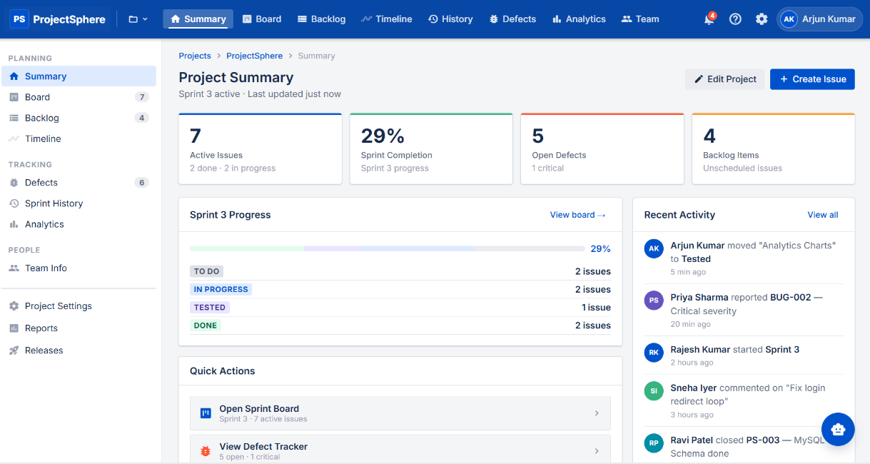

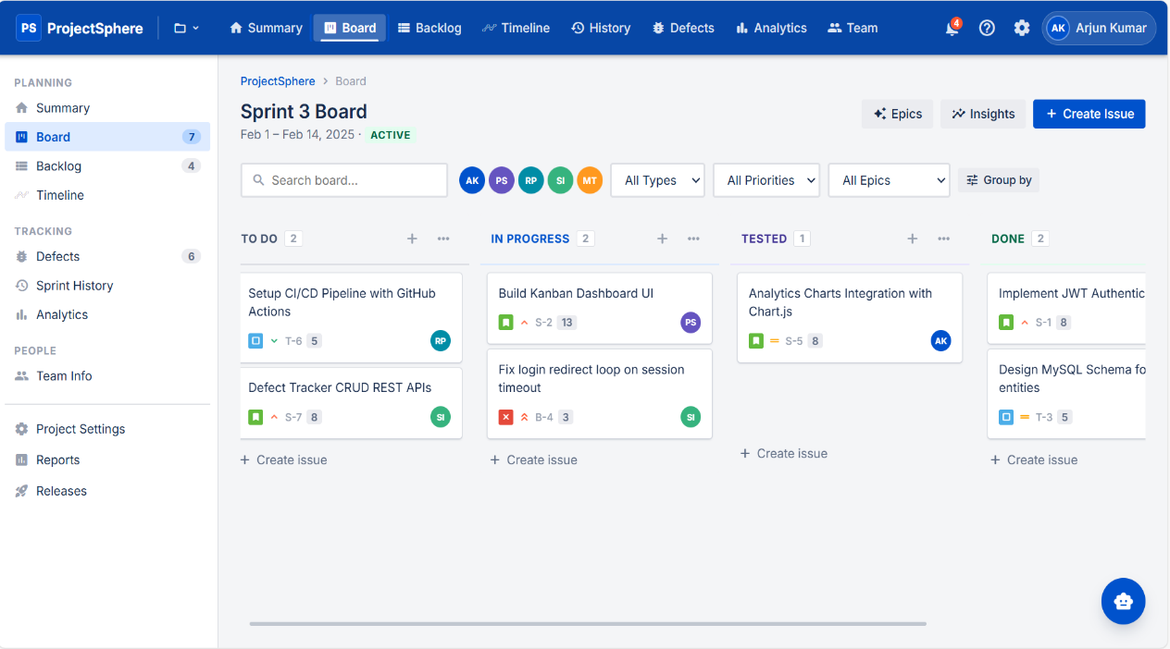

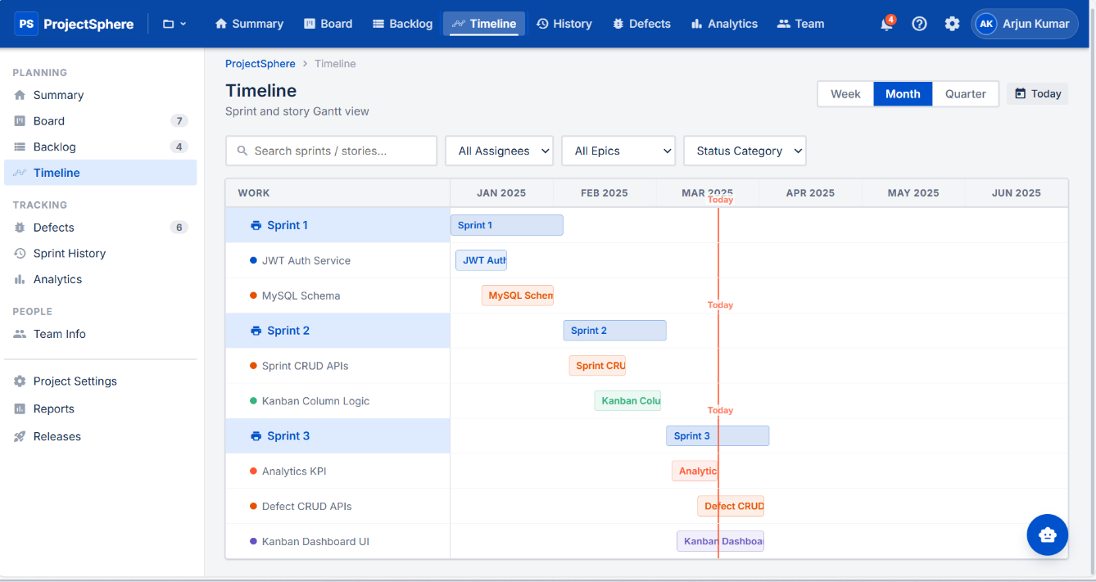
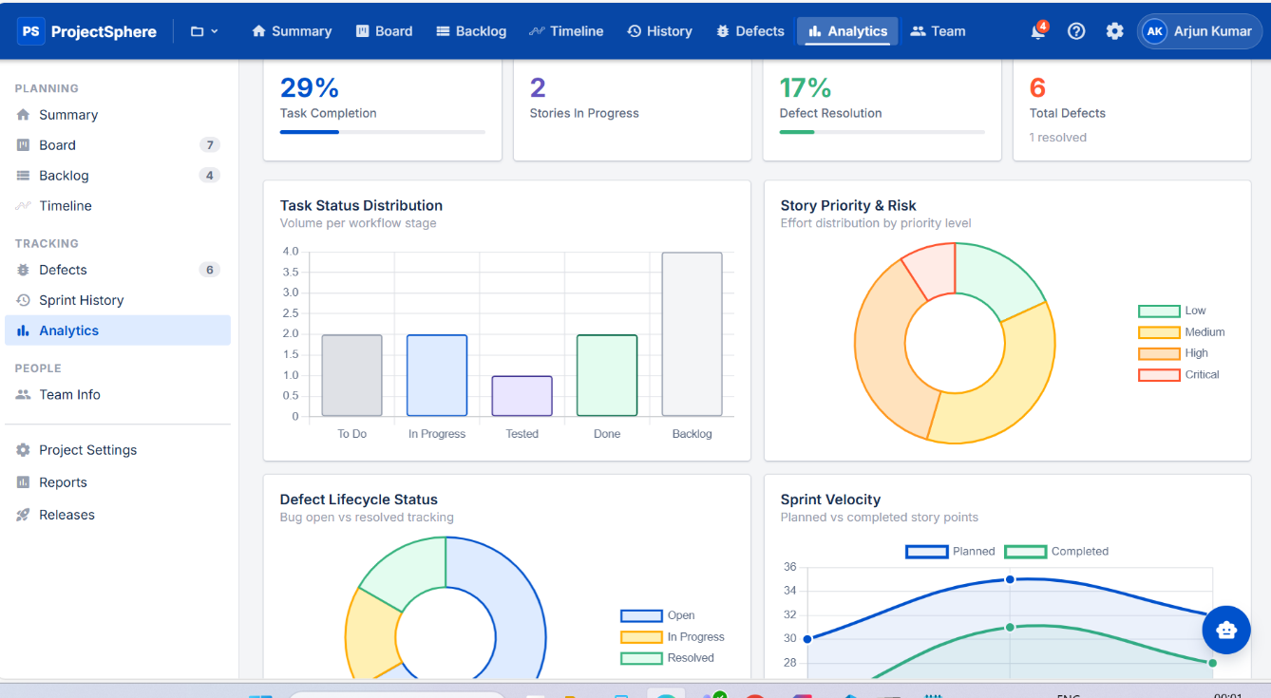

3.2 Project 2: Smart Temperature Converter

3.2.1 Project Description

The Smart Temperature Converter was developed as an interactive and user-friendly web application aimed at providing real-time weather information along with temperature conversion functionality. In traditional scenarios, users often rely on separate tools or static data sources for weather updates and unit conversions, which can be time-consuming and inefficient. This project was designed to overcome these limitations by integrating both functionalities into a single, dynamic platform that delivers accurate and real-time results.

The application allows users to select a state and corresponding city through dropdown menus. Based on the selected city, the system fetches real-time weather data using the OpenWeather API and displays essential details such as temperature, weather condition, wind speed, and air-related information. This ensures that users receive up-to-date and location-specific data instantly.

In addition to real-time weather updates, the application includes a temperature conversion module, enabling users to convert temperature values between units such as Celsius and Fahrenheit. The project also emphasizes enhanced user experience by incorporating dynamic features like weather-based animations (sunny, rainy, cloudy) that visually represent current conditions. Furthermore, graphical comparisons of temperatures between cities are provided to help users analyze variations effectively.

The application is designed with a strong focus on responsiveness and usability, ensuring seamless performance across desktops, tablets, and mobile devices. By combining real-time data integration, interactive design, and responsive layouts, this project demonstrates how modern front-end technologies can be effectively used to build practical and engaging applications.

3.2.2 Technologies Used

The Smart Temperature Converter was developed using a combination of HTML5, CSS3, Bootstrap, JavaScript, and OpenWeather API, forming a robust and efficient front-end technology stack.

HTML5 was used to define the structure of the application, including dropdowns for state and city selection, input fields for temperature conversion, and sections for displaying weather details. It ensured a clear and semantic layout, improving readability and maintainability of the code.

CSS3 and Bootstrap were used to design a visually appealing and responsive user interface. Bootstrap provided pre-built components such as cards, grids, and modals, which helped in creating a consistent and structured layout. CSS3 was used for custom styling, animations, and responsiveness through media queries, ensuring compatibility across different devices and screen sizes.

JavaScript played a central role in implementing the application’s logic. It was used for handling API calls, processing user inputs, updating the DOM dynamically, and controlling interactive features such as animations and charts. Event listeners were used to capture user actions and update the interface in real time.

OpenWeather API was integrated to fetch real-time weather data such as temperature, weather conditions, humidity, and wind speed. This integration made the application dynamic and practical, allowing users to access accurate and current information.

Together, these technologies created a lightweight, responsive, and interactive application that effectively handles real-time data and provides a smooth user experience.

3.2.3 Work Done
• User Interface Design:
- Designed intuitive dropdown menus for selecting Indian states and dynamically loading cities based on selection.
- Developed responsive layouts using Bootstrap cards and popup components to present weather data in a clean and organized manner.
- Ensured the interface is visually appealing, easy to navigate, and compatible with multiple devices.
• API Integration & Logic Implementation:
- Integrated OpenWeather API to fetch real-time weather data based on the selected city.
- Implemented JavaScript logic to handle API responses, extract required data, and update the UI dynamically.
- Added conditional logic to display weather-based animations such as sunny, rainy, and cloudy depending on temperature and weather conditions.

• Functionality & Features:
- Displayed detailed weather insights including temperature, air conditions, and wind speed using card popup components.
- Implemented graphical comparison of temperatures between different cities using charts for better visualization.
- Developed a temperature conversion module with support for multiple units and added a thermometer-style animation to visually represent temperature levels.
• Testing & Debugging:
- Conducted testing with multiple cities and weather scenarios to ensure correctness and reliability of data.
- Identified and resolved bugs during development and optimized performance for smooth execution and faster response.

3.2.4 Outcomes & Learnings

• API Integration & Real-Time Data Handling:
Gained in-depth knowledge of integrating external APIs and handling real-time data in web applications. Learned how to process API responses and display dynamic content efficiently.

• DOM Manipulation & Dynamic UI:
Enhanced skills in JavaScript DOM manipulation by creating interactive interfaces that update instantly based on user actions.

• Responsive Web Design:
Strengthened understanding of responsive design using CSS and Bootstrap, ensuring consistent performance across various devices and screen sizes.

• UI/UX & Data Visualization:
Learned to improve user experience by integrating animations, charts, and visual elements that make complex data easier to understand and more engaging.

• Real-World Application Development:
Developed confidence in building practical web applications by combining multiple technologies and implementing real-world features effectively.

3.2.5 Skills Gained During Internship

• Web Application Development
• JavaScript DOM Manipulation
• API Integration (OpenWeather API)
• Responsive Web Design
• Frontend Development (HTML, CSS, Bootstrap)
• Problem Solving & Logical Thinking
• Debugging and Testing

3.2.6 Tasks Assigned During Internship
• Developed ProjectSphere (Java Full Stack project)
• Built Smart Temperature Converter using JavaScript and API integration
• Designed responsive UI using HTML, CSS, and Bootstrap
• Implemented dynamic features, animations, and charts
• Tested application functionality with multiple scenarios
• Debugged errors and improved performance
3.2.7 Code Implementation
Weather.html:
<!-- Weather Form -->
<form class="weather-form" onsubmit="return false;">
<div class="form-group">
<label for="state">Select State:</label>
<select id="state" name="state">
<option value="">-- Select State --</option>
</select>
</div>
<div class="form-group">

<label for="city">Select City:</label>
<select id="city" name="city">
<option value="">-- Select City --</option>
</select>
</div>
<div class="form-actions">
<div class="unit-toggle" id="unitToggle">
<button type="button" class="unit-toggle__btn active" data-unit="celsius">°C</button>
<button type="button" class="unit-toggle__btn" data-unit="fahrenheit">°F</button>
<button type="button" class="unit-toggle__btn" data-unit="kelvin">K</button>
</div>
<button type="button" class="btn-continue">Continue</button>
</div>
</form>
<!-- Chart -->
<div class="chart-wrapper">
<canvas id="lineChart"></canvas>
</div>
<!-- History Sidebar -->
<aside class="weather-col-right">
<div class="weather-card weather-card--history">
<h2 class="weather-card__title">Recent Searches</h2>
<div id="historyList" class="history-list"></div>
</div>
</aside>
<!-- Modal -->
<div class="modal-overlay" id="weatherModal">
<div class="modal">
<button class="modal-close" id="modalClose">&times;</button>
<div class="temp-hero" id="tempHero">
<div class="temp-hero__inner">
<div class="temp-hero__content">
<p id="modalTitle">—</p>
<p id="conditionValue">--</p>
<h1 id="tempValue">--°</h1>
<p id="feelsLike">Feels like --°C</p>
</div>
<dotlottie-wc id="weatherLottie" autoplay loop></dotlottie-wc>
</div>
</div>
</div>

Weather.js
// Populate States
function populateStates() {
stateSelect.innerHTML = '<option value="">-- Select State --</option>';
Object.keys(stateCityMap).forEach(state => {
const option = document.createElement("option");
option.value = state;
option.textContent = state;
stateSelect.appendChild(option);
});
}
populateStates();
// Populate Cities
stateSelect.addEventListener("change", () => {
const selectedState = stateSelect.value;
citySelect.innerHTML = '<option value="">-- Select City --</option>';
if (selectedState && stateCityMap[selectedState]) {
stateCityMap[selectedState].forEach(city => {
const option = document.createElement("option");
option.value = city;
option.textContent = city;
citySelect.appendChild(option);
});
}
});
// Fetch Weather
continueBtn.addEventListener("click", async () => {
const city = citySelect.value;
const url = `https://api.openweathermap.org/data/2.5/weather?q=${city}&appid=${apiKey}`;
const response = await fetch(url);
const data = await response.json();
document.getElementById("modalTitle").textContent = city;
document.getElementById("conditionValue").textContent = data.weather[0].description;
document.getElementById("tempValue").textContent = `${(data.main.temp - 273.15).toFixed(1)}°C`;
modal.classList.add("active");
});
// Render History
function renderHistory() {
historyList.innerHTML = "";
history.forEach(entry => {
const card = document.createElement("div");
card.className = "history-card";
card.innerHTML = `<p>${entry.city} - ${entry.celsius}°C</p>`;
historyList.appendChild(card);
});
}
// Chart Comparison
btnCompare.addEventListener("click", () => {
const labels = history.map(h => h.city);
const values = history.map(h => parseFloat(h.celsius));
new Chart(document.getElementById("lineChart"), {
type: "line",
data: { labels, datasets: [{ label: "Temperature (°C)", data: values }] }
});
});

3.2.8 Result
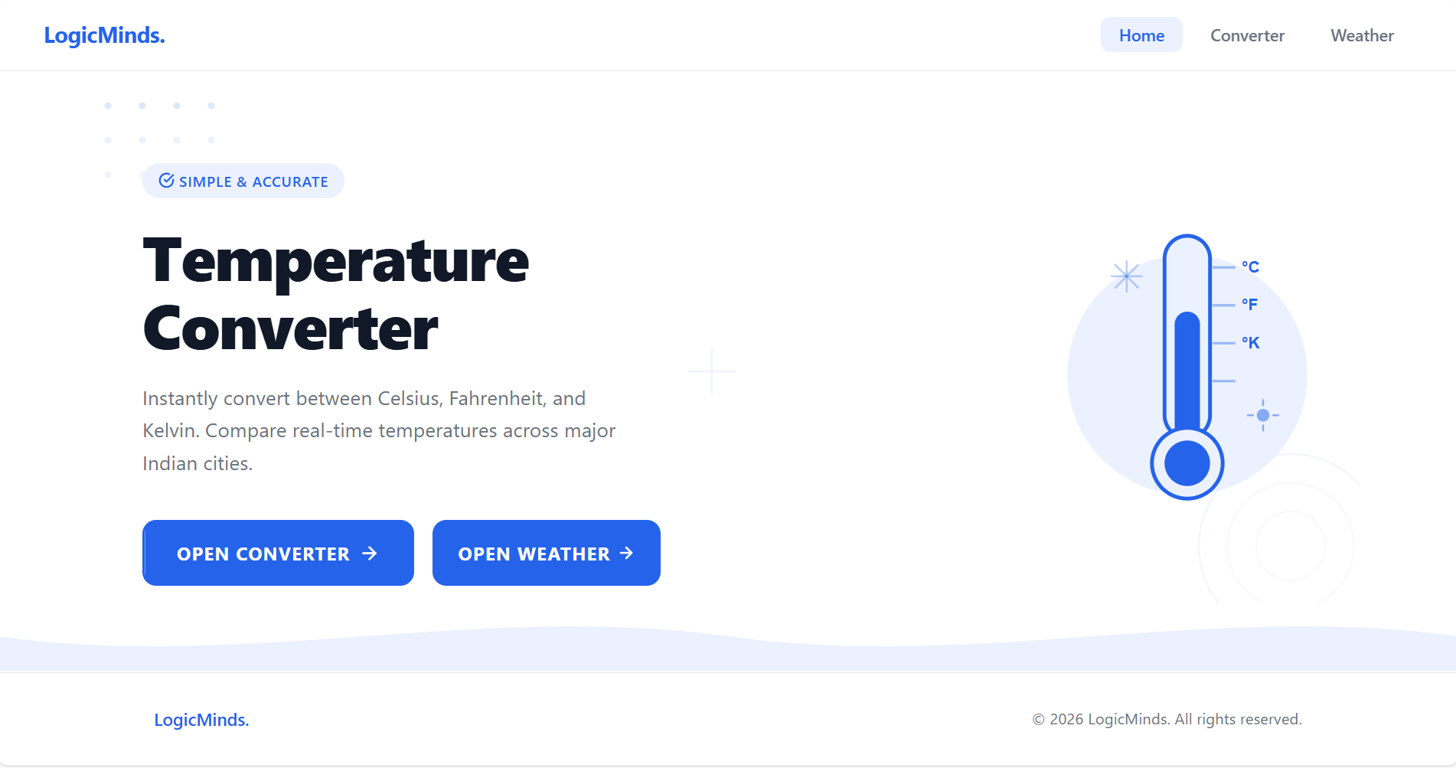
Figure 3.2.1 Smart Temperature Converter

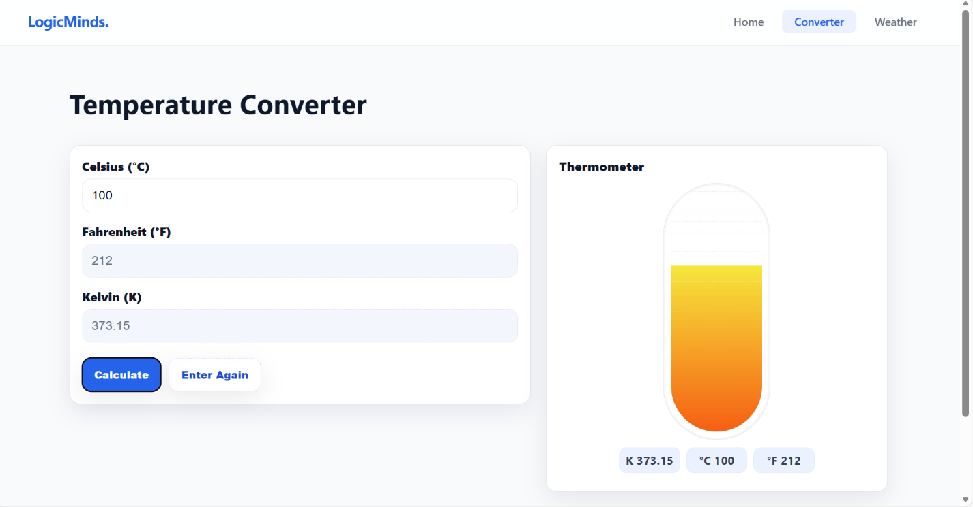

Figure 3.2.2 Bar Graph Representation of Monthly EMI

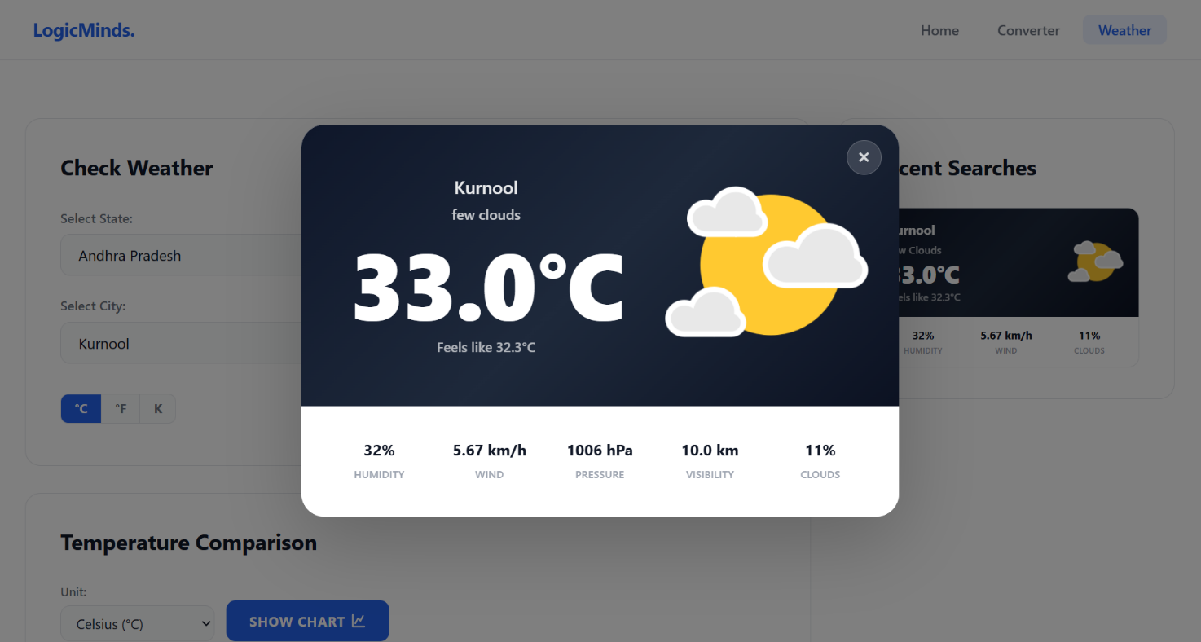

Figure 3.2.3 Amortization Table of Monthly EMI
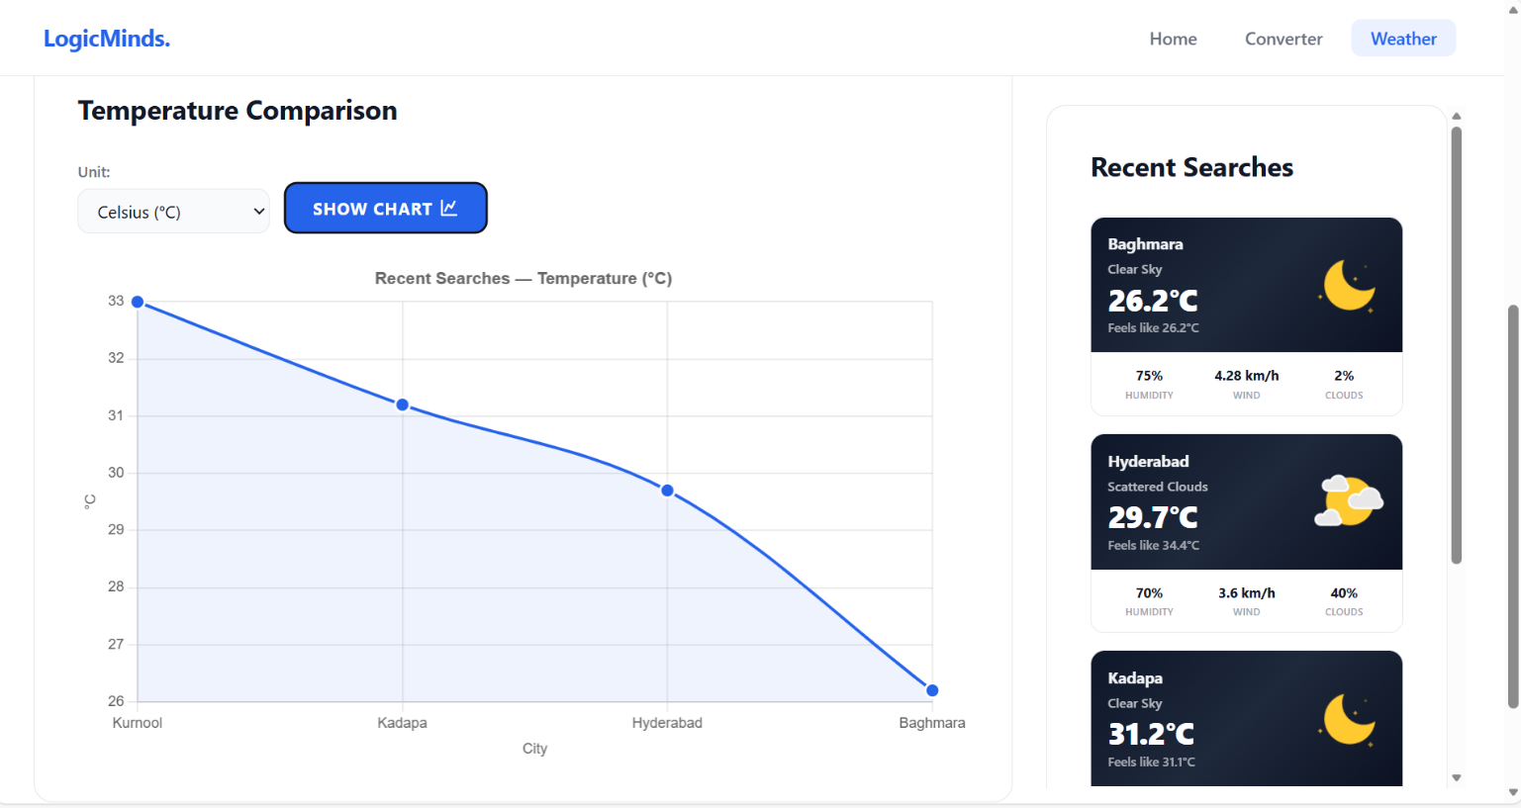

Figure 3.2.4 Speedometer and piechart

ACTIVITY LOG FOR THE WEEK

weeks | Description of the weekly activity | Learning Outcome | Person In- Charge Signature
Week 1 | Attended bootcamp orientation, explored the organization’s workflow, installed necessary software tools, and communicated with trainers, HR, and fellow trainees. | Developed communication skills, completed software installation and configuration, and adapted to the new environment.
Week-2 | Introduction to UI/UX design principles. Learned how to make websites interactive and attractive, focusing on user experience. Practiced application design using Figma. | Gained understanding of UI/UX fundamentals and hands-on practice in designing user-friendly interfaces.
Week 3 | Worked on application prototypes in Figma, creating interactive layouts and design flows for sample projects. | Improved design thinking and ability to translate user requirements into visual prototypes.
Week 4 | Started frontend development with HTML fundamentals including tags, forms, tables, and semantic elements. Created static web pages for practice. | Acquired knowledge of HTML structure and ability to design simple webpages.

Week 5 | Learned CSS fundamentals including selectors, box model, layout, background, text styling, and animations. | Gained skills in styling webpages and enhancing visual presentation.
Week 6 | Studied CSS Grid and layout design. Introduction to Bootstrap and created responsive layouts using Bootstrap components. | Learned responsive design and layout management.
Week 7 | Introduction to JavaScript basics including variables, data types, operators, control statements, and implemented a basic calculator. | Learned JavaScript fundamentals and logic building.
Week 8 | Studied functions, arrays, objects, loops, and DOM manipulation. Implemented interactive elements using JavaScript. | Improved DOM manipulation and dynamic webpage development skills.
Week 9 | Learned JavaScript OOP concepts, constructors, inheritance, and events handling. Worked on background generator exercise. | Gained knowledge of advanced JavaScript concepts.
Week 10 | Completed a mini-project: Smart Temperature Converter. Built an application to convert temperature between Celsius, Fahrenheit, and Kelvin, and integrated OpenWeather API for real-time data. | Hands-on experience in frontend application development and API integration.
Week 11 | Started Java programming. Learned OOP concepts, constructors, inheritance, and event handling. Explored JDBC with Maven and pom.xml configuration. Connected Java applications with databases. | Strengthened Java fundamentals and problem-solving skills.  Learned database connectivity and project setup using Maven.
Week 12 | Studied SQL concepts including create table, insert, update, delete, and join operations. | Gained knowledge of database management and SQL queries.
Week 13 | Studied Spring framework fundamentals including dependency injection, Spring REST, and WebMVC architecture. Practiced building simple RESTful services and controllers to handle HTTP requests. | Gained knowledge of Spring core concepts, REST API development, and MVC-based web application structuring.
Week 14 | Explored Spring Boot for rapid application development. Learned JPA, Data JPA, and Hibernate for database integration and ORM. Implemented CRUD operations and connected backend services with persistent storage. | Acquired practical skills in Spring Boot, ORM with Hibernate, and efficient database handling using JPA/Data JPA.
Week 15 | Final project development: Project Sphere. Built the frontend using Angular and backend using Spring Boot with REST APIs and JPA. Completed testing and documentation. | Practical experience in full-stack development, integrating frontend and backend technologies into a complete project.

CONCLUSION

During the course of my internship, I successfully completed two major projects: the Employee Management System and the EMI Calculator. These projects provided me with the opportunity to apply the theoretical concepts learned during training in a practical and real-world environment. By working on these applications, I was able to bridge the gap between academic knowledge and industry practices, gaining valuable hands-on experience in web development.

While working on the Employee Management System, I gained extensive exposure to full-stack development. I designed user interfaces using React, implemented CRUD operations through Spring Boot, and integrated a relational database using MySQL. This project helped me understand the importance of structured application development, modular design, and the separation of concerns between frontend, backend, and database layers. It also improved my ability to manage employee data efficiently, ensuring accuracy and reliability. The EMS project strengthened my skills in responsive design, API development, and database schema modeling, which are essential for building scalable enterprise-level applications.

The EMI Calculator project, on the other hand, focused primarily on front-end development and mathematical logic implementation. By using HTML, CSS, and JavaScript, I was able to design an interactive interface that allowed users to input loan details and instantly view EMI results. This project taught me how to handle user inputs effectively, perform dynamic calculations in real time, and display results in a clear and user-friendly manner. I also learned how to integrate visual elements such as charts and indicators to enhance user experience, making financial data easier to interpret. The EMI Calculator improved my skills in DOM manipulation, event handling, and responsive web design, while also boosting my confidence in developing lightweight, practical tools for everyday use.

Overall, working on these two projects significantly improved my technical knowledge, problem-solving ability, and debugging skills. The internship provided me with a strong foundation in both frontend and backend development, allowing me to understand the complete workflow of real-time project implementation. It also gave me insight into industry practices such as testing, validation, and optimization, which are crucial for delivering reliable applications.

Most importantly, this internship increased my confidence in developing user-friendly and responsive web applications. By successfully completing both projects, I demonstrated my ability to work with modern technologies, adapt to challenges, and deliver functional solutions. The experience has prepared me to take on more complex projects in the future and has strengthened my readiness for professional roles in the field of web development.

References

- Spring Initializr
- https://docs.oracle.com/en/java/
- https://spring.io/projects/spring-boot
- https://hibernate.org/orm/documentation/
- https://react.dev/
- https://dev.mysql.com/doc/
- https://www.w3schools.com/
- https://developer.mozilla.org/
- https://www.tutorialspoint.com/java/index.htm
- Maven Repository: Search/Browse/Explore

